**HTML Basics**

**Overview**

This project is the first step in the creation of a travel photo sharing website. The page you are given is augmented by this project to add a Related Photos section to the page. Edit project01.html so the page looks similar to that shown in Figure 1

**Instructions**

1. Open project01.html in the editor of your choice, so you can start making changes.
2. Start by putting the main elements that you see in figure 1. All images are given to you. Try to make your page similar to the figure as much as you as can.
3. Make the href attribute point to # for the moment in the list that contains Descriptions, Related Photos and Reviews.)
4. Include all the elements the "Related Photos" section at the bottom of the page using <section> tag (container).
5. In the "Related Photos" section, add three images from the ones provided in the images folder. Use the small images related-square1.jpg, related-square2.jpg, and related-square3.jpg in the src of your <img> tag, but link them to the large images with almost the same names. The large images should be opened in a new tab when you click the small image.

**Test**

1. Firstly, test your page by seeing if it looks like the one in Figure 1.
2. Now check that the link correctly links the Related Photos link to the "Related Photos" section, and that clicking on the related images brings up the larger versions.
3. Validate the page by pasting the HTML into <http://validator.w3.org/> and ensure that it displays the message: This document was successfully checked as HTML5!

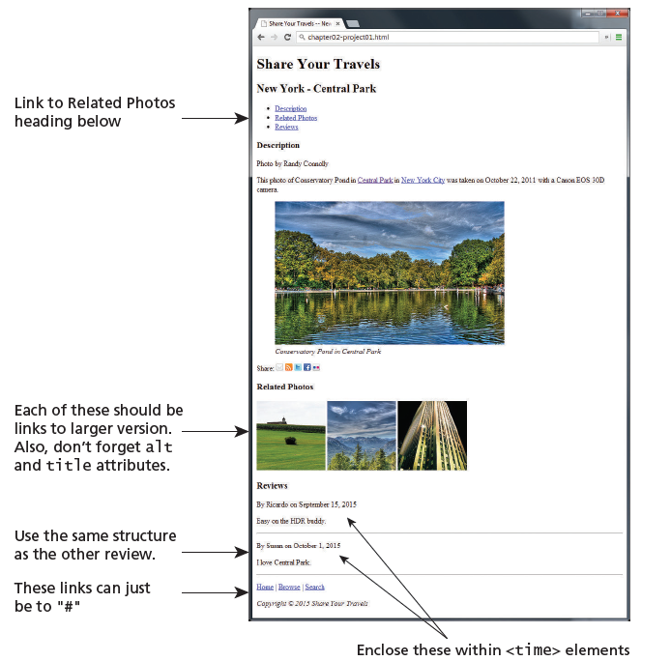

Figure Completed Answer